**Chapter 11**

**Introduction to medical applications and Mixed Reality**

1- The applications of computers in medicine field

2- The role of computer graphic in healthcare

3- Medical imaging

4- Algorithms and Techniques

5- Applications and Innovative Projects

6- Virtual reality and the Future of Healthcare

7- The role of augmented reality in healthcare

The medical domain provides excellent opportunities for the application of computer graphics, visualization and virtual environments, with the potential to help improve healthcare and bring benefits to patients.

**7.1. The application of commuters in medicine**

The application of computer techniques in various fields of medicine is briefly discussed below:

**Hospital information system**

Medical informatics is a rapidly growing discipline. It seeks to organize and manage information in support of patient care, biomedical research and education through the aid of computer and information networks

### Data Analysis in Medicine

In medical research large numbers of data are collected. This data is to be compiled, analyzed and interpreted.

### Laboratory Computing

The primary objective of a clinical laboratory is to provide accurate results in a short time. Laboratory analysis includes blood chemistry, photometry, microbiology, etc. Results must match with patient identification details and should be valid. Quick access to laboratory systems can contribute to an efficient patient care system.

### Computer Assisted Decision making (CMD)

It is an interactive computer system that directly assists doctors with clinical decision making tasks. The system is intended to support doctors, complementing their natural abilities to make judgment with the computer's vast memory, reliability and processing capabilities.

**Care of critically ill patients**

Critically ill patients require a large number of therapeutic interventions to optimize their chances of survival. For this, the variables must be collected frequently and the data derived therefrom made available to the clinicians and nursing staff.

### Computer assisted therapy

Methods for planning, monitoring and adjusting dosages regimens of powerful and potentially toxic drugs, e.g. digitalis and antibiotics like gentamicin have been developed. The physician can plan dosage regimens by selecting a target peak total body concentration of a drug.

### Medical imaging

During the last decade computers were commonly used for high resolution image generation. Dedicated hardware and software is required to generate such images in CT scan, MRI, ultrasound, and gamma cameras. It is possible to integrate these workstations to the main hospital information system. Three dimensional images of living human anatomy, regional physiology and biochemistry in health and diseases are in use.

**7.2. The role of computer graphic in healthcare**

Computer graphics have played a significant role in the advance of medicine. Since the mid 1970's, when the first three-dimensional visualizations of Computed Tomography 1 were reported, computer graphics have evolved to aid the medical profession in various aspects such as diagnosis, procedures training, pre-operative planning and telemedicine

The use of computer graphics for medical diagnosis has provided an extraordinary ability to visualize, measure and evaluate structures in a non-intrusive manner.

One of the most important areas in medicine where computer graphics have had a positive impact is training. Computer graphics provide new methods for learning, as professionals can test their skills in simulators and evaluate their performance in a virtual environment. Whereas traditional training in the medical area involved a great number of dissections in order to correctly learn about the human anatomy, computer graphics have provided 3D models that can be easily explored and interacted with. This allows the professional not only to use a 3D model as a biography atlas but also interact with it to perform surgery rehearsals.

In the last few years, the area of medical simulators has grown to be an important part of medical training. With the use of simulators, professionals can learn how to proceed with delicate operations without endangering human subjects. This is only possible by using high resolution 3D graphic representations of parts of the human body alongside mechanical instruments that convey the interaction between the user and the simulator system.

**Example**:

An important aspect of education-related medical graphics applications is the creation of simulators. Several companies have developed highly advanced simulator systems for medical training. A good example can be found within the products of the company Voxel-Man (Voxel- Man, 2009). Voxel-Man products include several surgery simulators that allow the user to interactively practice delicate procedures such as brain surgery without the need of real patients or cadavers. Furthermore, the company has developed dental procedure simulators for dental professionals.

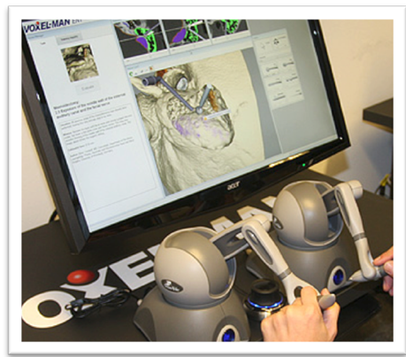

**Voxel-Man's Tempo simulator**

**7.3. Medical imaging**

· The increasing availability of high resolution, volumetric imaging data (including multi‐detector CT, high field strength Magnetic Resonance (MR), rotational angiography and 3D ultrasound) within healthcare institutions has particularly impacted on the specialties of Surgery, Radiology and other clinical areas where such data are in widespread use for diagnosis and treatment planning. There has been a paradigm shift in our ability to visualize, evaluate and measure anatomical and pathological structures which has overtaken and all but eliminated previous invasive diagnostic modalities and diagnostic surgical exploration (laparotomy). The ability to diagnose smaller abnormalities is improving the early detection and management of sinister diseases such as cancer.

· Medical imaging refers to several different technologies that are used to view the human body in order to diagnose, monitor, or treat medical conditions. Each type of technology gives different information about the area of the body being studied or treated, related to possible disease, injury, or the effectiveness of medical treatment.

· Imaging is a useful resource for musculoskeletal conditions and is an invaluable tool for physical therapists when used appropriately. Imaging such as MRI, X-ray, CT scans, and bone scans are prime examples of practical diagnostic imaging that facilitates accurate diagnosis, prognosis, intervention, and assessment of injuries and dysfunctions that physical therapists address on a daily basis.

|  |  |
| --- | --- |
| X-ray radiography | Create 2D images  An imaging technique which uses beams of electromagnetic waves (x-rays) to produce radiographs that depict the tissues in two dimensions based on their density.  Commonly used for assessment of chest, abdominal and skeletal anatomy. |
| Computed tomography (CT) | Create 3D images  An imaging technique which uses X-ray beams to produce images that depict the tissues in two and three dimensions based on their density.  Commonly used for assessment of musculoskeletal systems, parenchyma of solid organs, distribution of body fluids. |
| Magnetic resonance imaging (MRI) | An imaging technique which uses radio-waves and magnetic fields to produce images based on the tissue’s proton (hydrogen) levels.  Commonly used for examination of soft and nervous tissues. |
| Ultrasonography (U/S) | An imaging method which uses high frequency sound waves to depict tissues based on their density.  Wide array of indications (e.g. Doppler U/S, breast U/S, obstetric U/S) |
| Nuclear medicine | Spectrum of imaging methods used for examining the function of specific body parts by using gamma-radiation emitting radiopharmaceuticals (radioactive pharmaceuticals)  Common method: PET scan |

|  |  |
| --- | --- |
| X-ray image | CT image |
| **In order to make an image, X rays use radiation.** | In order to make an image, CT rays use radiation. |
| **x-ray is a static image of a single image that was previously created on a movie, but now created by means of a digital image.** | CT scans are a dynamic analysis in a 360 ° revolving x-ray tube in a patient portal that generates individual "slices" of a specific area or creates a three-dimensional image of that area. |
| **The resolution of CT is much smaller than plain x-rays** | The resolution of CT is much greater than plain x-rays |
| **Just one image at a time will conventional x-ray machines take.** | Computerized tomography (CT) scans, also called CAT scans, transform around the body and image hundreds from several angles. |
| **Every other internal structure, such as the organ, can be viewed by X-ray.** | A CT scan creates detailed organ images |
|  | The CT scanner is like a big structure like a box in the middle with a tunnel. |
| **Less expensive** | more expensive than an X-ray |

**7.4. Algorithms and Techniques**

The section is divided into four parts. First, it describes the filtering and segmentation steps which act as a pre‐processing of medical image data before application of a visualization technique. Secondly, it discusses the main approaches to the visualization of volumetric data in medicine. It then provides an overview of the main techniques used for combining two or more image modalities of the same patient—often called image fusion or 3D image registration. Finally, it summarizes the algorithms being used for soft tissue modeling—an important component of a medical virtual environment.

### Filtering and segmentation

Image data acquired from a scanner will inevitably contain noise. Many ***filtering*** techniques have been proposed in order to remove the noise, typically smoothing by replacing the value at each voxel by some averaging over a local neighborhood. However, in medical applications, this smoothing can blur the boundaries of anatomical features. A better approach for medical data is to use an anisotropic diffusion‐based technique where the image intensity values iterate toward an equilibrium state, governed by an anisotropic diffusion partial differential equation. The diffusion function depends on the magnitude of the gradient of the intensity, and so diffusion occurs within regions, where the gradient is small, and not across region boundaries where the gradient magnitude is high.

The next step is to apply a ***segmentation*** algorithm to identify different parts of the anatomy of particular interest. This will label voxels with an identifier indicating the type of material. The process typically remains semi‐automatic, with user guidance needed in order to help correct identification. Indeed, segmentation is often the major bottleneck in clinical applications—it takes a long time and the results are often hard to reproduce because of the user involvement.

Many segmentation techniques are based on the concept of deformable models where an initial shape is evolved to fit as closely as possible a feature in the image.

### Volume visualization

A simple approach to visualizing a volume is to visualize a series of slices, either parallel to one of the faces of the volume, or in an oblique direction. This is often called multiplane reformation (or MPR) and is arguably the most popular visualization technique in clinical practice. Radiologists are trained to move through the slices and to recognize branching patterns through this process. Their experience in moving through 2D slices in this manner allows them to build a 3D mental model of the real anatomy.

· Volume visualization is the creation of graphical representations of data sets that are defined on three-dimensional grids. Volume data sets are characterized by multidimensional arrays of scalar or vector data. These data are typically defined on lattice structures representing values sampled in 3-D space. There are two basic types of volume data:

* *Scalar volume data* contains single values for each point.
* *Vector volume data* contains two or three values for each point, defining the components of a vector.

**Selecting Visualization Techniques**

· The techniques you select to visualize volume data depend on what type of data you have and what you want to learn. In general,

* **Scalar data** is best viewed with isosurfaces, slice planes, and contour slices.
* **Vector data** represents both a magnitude and direction at each point, which is best displayed by stream lines (particles, ribbons, and tubes), cone plots, and arrow plots. Most visualizations, however, employ a combination of techniques to best reveal the content of the data.

**Steps to Create a Volume Visualization**

Creating an effective visualization requires a number of steps to compose the final scene. These steps fall into four basic categories:

1. Determine the characteristics of your data. Graphing volume data usually requires knowledge of the range of both the coordinates and the data values.

2. Select an appropriate plotting routine. The information in this section helps you select the right methods.

3. Define the view. The information conveyed by a complex three-dimensional graph can be greatly enhanced through careful composition of the scene. Viewing techniques include adjusting camera position, specifying aspect ratio and project type, zooming in or out, and so on.

4. Add lighting and specify coloring. Lighting is an effective means to enhance the visibility of surface shape and to provide a three-dimensional perspective to volume graphs. Color can convey data values, both constant and varying.

**Image fusion**

With the abundance of medical imaging technologies and the complementary nature of the information they provide, it is often the case that images of a patient from different modalities are acquired during a clinical scenario. To successfully integrate the information depicted by these modalities, it is necessary to bring the images involved into alignment, establishing a spatial correspondence between the different features seen on different imaging modalities. This procedure is known as ***Image Registration***. Once this correspondence has been established, a distinct but equally important task of ***Image Fusion*** is required to display the registered images in a form most useful to the clinician and involves the simultaneous rendering of different modalities. Multimodal rendering is an active research area that includes 3D direct volume rendering of multimodal data sets, analyzing how and where data fusion should occur in the rendering pipeline, and how rendering algorithms can be adapted and optimized for multimodal data sets.

Image registration techniques have been applied to both monomodality and multimodality applications. Registration of images from multiple modalities is generally considered a more difficult task. Nevertheless, there are significant benefits to the fusion of different imaging modalities. For example, in the diagnosis of epilepsy and other neurological disorders, it is common for a patient to undergo both anatomical (MRI, CT, etc.) and functional (PET, fMRI, EEG) examinations. Image guided surgery also makes extensive use of pre‐operatively acquired imaging data and intra‐operatively generated surface imaging and/or ultrasound for procedure guidance.

### Soft‐tissue modeling

The purpose of soft‐tissue modeling is to enable the simulation of tissue behavior. This is required in a variety of applications including surgical simulators for training, intra‐operative deformation modeling and surgical planning. In general, soft‐tissue modeling algorithms can be classified as either *geometrically‐based* or *physically‐based*. With geometrically‐based modeling, the shape of an object is adjusted by changing the position of some control points, or by adjusting the parameters of an implicit function defining the shape. A typical example of this type of technique is free‐form deformations (FFD), where the object is embedded into a lattice of a simple shape. Deformation of the lattice causes a consequent deformation of the object. These methods are often fast, but the object deformation is carried out indirectly and may bear little or no resemblance to the physically plausible deformation. Recent research has focused on improving the user interaction with the objects to allow direct manipulation.

In contrast, physically‐based modeling methods attempt to mimic reality by embedding the material properties and characteristic behavior of the object into a suitable model. Physics laws govern the movement of object elements. These methods can explicitly represent the real life, dynamic behavior of objects. Object deformation is applied in an intuitive manner, typically by interacting directly with the object. One of the most widely used approaches in physically‐based modeling is the mass‐spring technique.

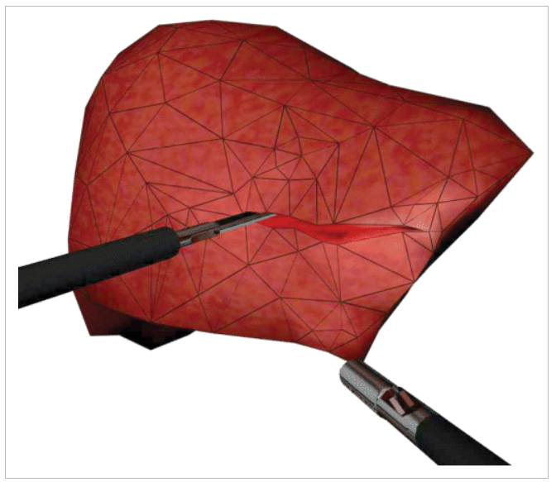

*Adaptive soft‐tissue modeling with cutting and grasping.*

**7.5. Applications and Innovative Projects**

### Educational tools

Traditional teaching of human anatomy involves dissection. The benefits include a spatial understanding which is difficult to glean from textbook demonstrations. Traditional methods are now less commonly used, having been largely replaced by problem‐based learning scenarios and pre‐dissected specimens. Yet there are developing deficiencies in the anatomical knowledge of today's medical graduates, and such information is vital to their future practice in specialties such as surgery and radiology. A substitute for the traditional, interactive methods exists in the application of virtual environments where anatomy can be explored in 3D, providing new educational tools ranging from three‐dimensional interactive anatomical atlases to systems for surgery rehearsal.

### Diagnostic aids

CT and MR scanners can provide 3D data sets of 1000 image slices or more, but only around 20 to 60 hard copy images can be displayed on a typical light box. Consequently, thorough assessment of a complete volume data set requires mental reconstruction to provide the viewer's own 3D interpretation from those relatively few 2D images. Today's radiologists, when reporting medical imaging, will generally use a proprietary workstation, with much reporting work based on review of axial images, often using interactive movie scrolling to rapidly evaluate the multiple slices. Exploring off‐axial (multiplanar) 2D reconstruction can also provide valuable demonstration of anatomical relationships.

### Virtual endoscopy

In video or optical endoscopy, an endoscope (made from a fibre optic tube) is inserted into the patient body through a natural or minimally invasive opening on the body. It is an invasive process and only a limited number of structures can be viewed by the camera positioned at the tip of the endoscope. Virtual Endoscopy (VEnd) is a visualization technique that provides the same diagnostic information to the clinician by creating a 3D model from a medical scan of the patient. VEnd is not invasive (except for the radiation produced by a CT scan) and enables visualization of any structure, providing for interactive exploration of the inner surface of the 3D model while being able to track the position of the virtual endoscope. The clinician can also record a trajectory through the organ for later sessions, and create a movie to show to other experts.

### Treatment planning aids

The use of medical imaging and visualization is now pervasive within treatment planning systems in medicine. Typically, such systems will include a range of visualization facilities (e.g. virtual resection, fusion of images, measurement and analysis planning tools and often facilities for the rehearsal of operations and risk analysis.

### Guiding aids

In the last twenty years, surgical techniques have undergone radical change. A growing number of procedures are now conducted using a *minimally invasive* approach, in which surgeons operate with instruments passed through small holes in the patient, not much larger than a centimeter in diameter. There are significant benefits to minimal invasion, such as reduced patient trauma, reduced blood loss and pain, faster recovery times and, as a result, reduced cost. However, by keeping the surgeon's hands out of the patient, we incur the cost of occluding the view of the surgical field. A high resolution miniature video camera inserted through an access port is depended upon to act as the eyes of the surgical team, who view the operation on monitors in the operating theater. A number of minimally invasive surgical systems now provide color and dual‐camera configurations for stereo‐vision capability. There are limits to this approach, however. Traditional optical imaging technology cannot be used to see within organs, or around corners, and so the range of treatments that can be accommodated in this way is restricted. If minimally invasive techniques are to prevail over their more traditional techniques across more surgical interventions, new and more capable means of guidance are necessary.

*Image‐guided surgery* is the term used to describe surgical procedures whose planning, enactment and evaluation are assisted and guided by image analysis and visualization tools.

All neurosurgical interventions require considerable planning and preparation. At the very first stage, anatomical MR or CT images are taken of the patient's head and brain, and transferred to a supporting IT infrastructure. Specialist hardware is used to reconstruct the scanned images both as two‐dimensional and three‐dimensional views of the data. Pre‐surgical planning tools allow a thorough review of all images obtained. Furthermore, the surgeon is able to interact with a three‐dimensional visualization of the data by changing the viewing angle, adjusting the transparency and colouring of different brain structures, removing skin and bone from the image and so on. In addition, virtual instruments can be manipulated within the simulation, and their position and trajectory through the skull and brain displayed in real time. These features provide considerable assistance in the general decision‐making process of surgical planning.

### Skills training aids

The teaching of medical knowledge has for eons been a tradition where a major part of this process has been the teaching of clinical skills in an apprenticeship. Training on patients is associated with discomfort and provides limited access to the range of training scenarios required for full experience. This creates difficulty training in a time efficient manner. In surgery, and in particular, laparoscopic surgery, the requirement for completely new, specialist clinical skills, has driven the development of novel solutions to training. Skills boxes and other bench models have been shown to accelerate the acquisition of skills. Fixed models and mannequins have also been shown to be of value in training skills in interventional radiology (IR), for example, using vascular models produced by rapid prototyping to train in catheterization skills.

**7.6. Virtual reality and the Future of Healthcare**

· A lot of people think of VR as it relates to gaming and entertainment devices, but when used in a positive way, VR can be a profound benefit to human health. Whereas virtual reality replaces your vision, augmented reality adds to it.

**Augmented reality (AR)** adds digital elements to a live view often by using the camera on a smartphone. Examples of augmented reality experiences include Snapchat lenses and the game Pokémon Go.

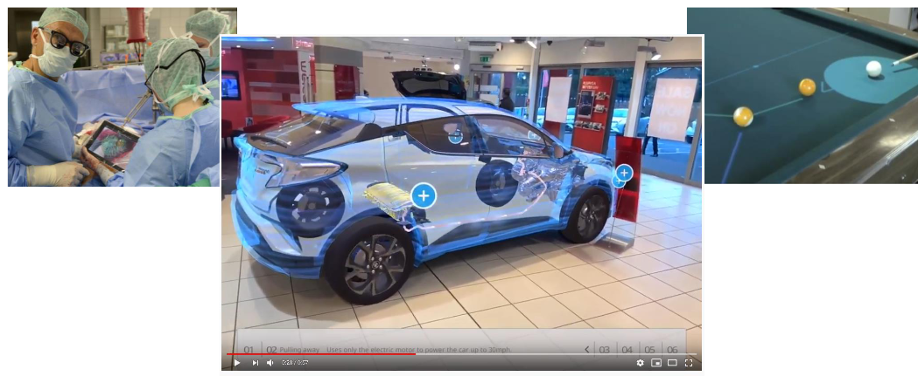

**Virtual reality (VR)** implies a complete immersion experience that shuts out the physical world. Using VR devices such as HTC Vive, Oculus Rift or Google Cardboard, users can be transported into a number of real-world and imagined environments such as the middle of a squawking penguin colony or even the back of a dragon.

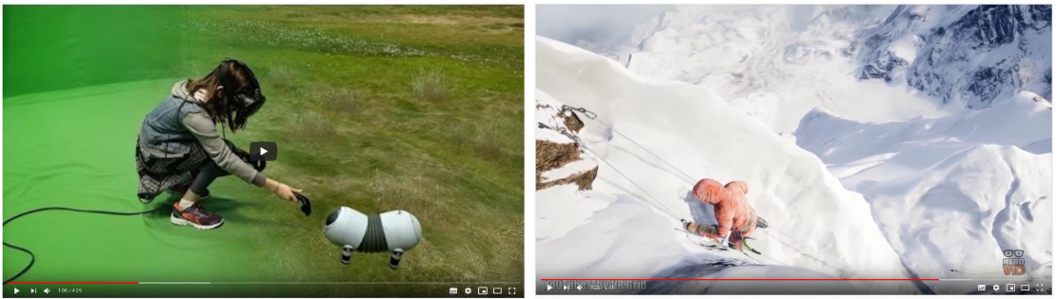

In a **Mixed Reality (MR)** experience, which combines elements of both AR and VR, real-world and digital objects interact. Mixed reality technology is just now starting to take off with Microsoft’s HoloLens one of the most notable early mixed reality apparatuses.

**Extended Reality (XR)** is an umbrella term that covers all of the various technologies that enhance our senses, whether they’re providing additional information about the actual world or creating totally unreal, simulated worlds for us to experience. It includes Virtual Reality (VR), Augmented Reality (AR) and Mixed Reality (MR) technologies.

**Using Virtual Reality Technologies**

From gaming, to movies, to medicine, the uses for Virtual Reality, Augmented Reality, and Mixed Reality are expanding.

* **Healthcare**—For training, such as for surgical simulations
* **Film and TV**—For movies and shows to create unique experiences
* **Virtual travel**—For virtual trips to an art museum—or another planet—all from home
* **Professional sports**—For training programs like STRIVR to help pro and amateur athletes
* **Gaming**—For over 1,000 games already available, from first-person shooters to strategy games to role-playing adventures

· Virtual Reality started its fascinating take-over of healthcare for the greatest pleasure of patients and doctors alike. Here are five great examples of medical VR transforming patient lives and how doctors work.

· Medical VR is an area with fascinating possibilities. It has not just moved the imagination of science-fiction fans, but also clinical researchers and real-life medical practitioners. Although the field is relatively new, there are increasingly great examples of VR having a positive effect on patients’ lives and physicians’ work

**1) Watching operations as if you wielded the scalpel**

Virtual reality could elevate the teaching and learning experience in medicine to a whole new level. Today, only a few students can peek over the shoulder of the surgeon during an operation and it is challenging to learn the tricks of the trade via this method. With a virtual reality camera, surgeons can stream operations globally and allow medical students to actually be there in the OR using their VR goggles.

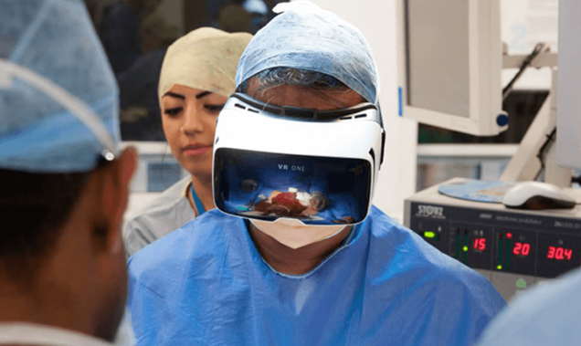

**2) Relaxing patients with Medical VR**

Earlier studies with patients suffering from gastrointestinal, cardiac, neurological and post-surgical pain have shown a decline in their pain levels when using VR to distract them from painful stimuli.

**3) Real conferences with virtual reality for an enhanced experience**

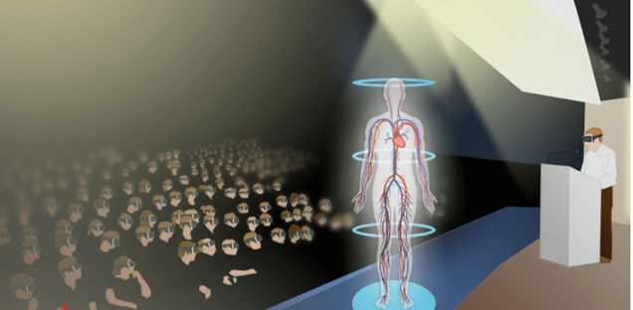

**4) Helping physicians experience life as the elderly**

**5) Speeding up recovery in physical therapy**

For patients who survived a stroke or traumatic brain injury, time is of the essence. The earlier they start rehabilitation; the better chances they have for successfully regaining lost functions.

Bringing a gamified approach to physical therapy for such patients is Neuro Rehab VR. Collaborating with physicians and therapists, the company develops VR training exercises with machine learning so as to tailor each exercise to patients’ therapeutic needs. The aim is to make physical therapy more enjoyable so as to increase patient engagement.

**7.7. The Impact of Augmented Reality in Healthcare**

· Augmented reality (AR) is gaining prominence in a wide range of areas. Everything from autonomous cars, video games, healthcare products, and space programs has benefited significantly from AR capabilities.

· Coined in the 1990s by Boeing researcher Thomas P Caudell, the term “augmented reality” refers to the software systems that overlay digital information onto physical objects. Augmented reality allows for the integration of virtual objects i.e images, texts, and effects to enhance the real-world experience of users.

· Unlike virtual reality, which occurs in virtual environments, augmented reality interacts with the physical world and superimposes virtual, visual information on top it, allowing us to experience our environments in a more dynamic and engaging way.

· In healthcare, AR is paving a new way for medical professionals to learn, deliver personalized care and save lives. The potential of AR is immense and far-reaching. Here are some key areas in healthcare that AR is already making a huge difference. There are many applications such as:

o Telemedicine

o Surgery

o Medical Training

o Equipment Training, Demos and Sales Coaching

Augmented and Virtual Reality

# Augmented reality[1]

Augmented reality (AR) technology adds layers of digital snippets on top of an existing environment, bridging the gap between the virtual and physical world. Using a device’s camera, digital content such as graphics, sound, and video, is displayed on-screen to deliver augmented experiences. Unlike [virtual reality](https://learn.g2.com/virtual-reality), augmented reality isn’t a fully immersive, artificial experience. Instead, it’s comprised of virtual components placed in your immediate surroundings.

## What is augmented reality used for?

Augmented reality is used to enhance everyday experiences, manipulating digital content to transform physical space. There are several industries that are leveraging the power of AR to create better learning environments in educational settings or customer experiences for retail purchasing and other business objectives.

Augmented reality is altering the way people consume content, whether they are learning about geography in a classroom, playing a video game, or building new products and parts.

# Types of augmented reality

There are several types of augmented reality in use today. From marketing to gaming, there are a lot of businesses in the exploration phase of utilizing this emerging technology. The question is… how? Easier asked than answered.

To get a better understanding of how you can use AR, let’s walk through the different types and see examples of each.

## Types of AR:

1. Marker Based
2. Markerless AR
   1. Location based
   2. Super-imposition
   3. Projection based
   4. Outlining

## Marker-based AR

Marker-based AR uses markers to trigger an augmented experience. The markers, often made with distinct patterns like QR codes or other unique designs, act as anchors for the technology. When a marker in the physical world is recognized by an augmented reality application, the digital content is placed on top of it.

Marker-based augmented reality is commonly used for marketing and retail purposes. Think business cards that speak and brochures that move.

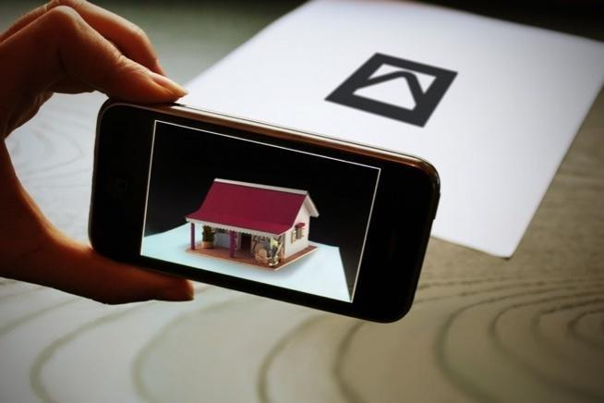

In this example, marker-based AR is being used for retail purposes in someone's home. Imagine if you could see what your new bathroom vanity would look like before you actually buy it. Plus, with this application, you can swipe through the various sink options to see what looks best in the space.

## Markerless AR

Marker-less AR is more versatile than marker-based AR as it allows the user to decide where to put the virtual object. You can try different styles and locations completely digitally, without having to move anything in your surroundings.

Markerless augmented reality relies on the device's hardware, including the camera, GPS, digital compass, and accelerometer, to gather the information necessary for the AR software to do its job.

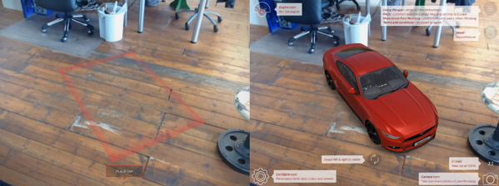

In this example, the virtual car can be positioned anywhere, regardless of the surrounding area. You can customize the Mustang itself, adjust and rotate the view, and learn additional product information.

The following types of augmented reality technically fall under the umbrella of markerless AR in that they don’t need a physical marker to trigger the digital content.

## Location-based AR

Location-based AR ties digital content and the experience it creates to a specific place. The objects are mapped out so that when a user's location matches the predetermined spot it is displayed on the screen.

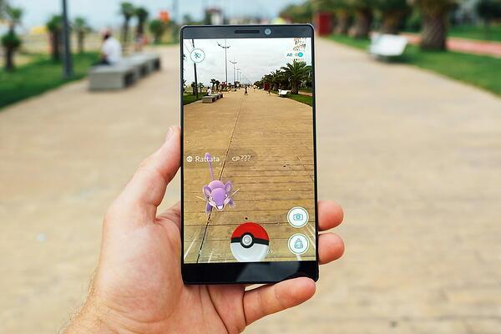

The game that brought augmented reality to the masses, Pokemon Go, is an example of location-based AR. The experience brings virtual Pokemon to our world through your smartphone and users are encouraged to find as many of the characters as possible.

## Superimposition AR

Superimposition AR recognizes an object in the physical world and enhances it in some way to provide an alternate view. This can include recreating a portion of the object or the whole thing in its entirety.



In this example, the chair is copied, rotated, and placed in another location around the table. The user can do so many things with this technology, like decide if they want to have four chairs and a little elbow room or if they can comfortably seat six at the same table.

## Projection-based AR

Projection-based AR is a little different than the other types of markerless augmented reality. Namely, you don’t need a mobile device to display the content. Instead, light projects the digital graphics onto an object or surface to create an interactive experience for the user.

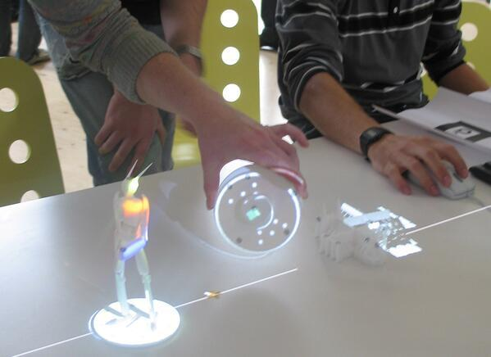

Yes, that’s right, holograms! Projection-based AR is used to create 3D objects that can be interacted with by the user. It can be used to show a prototype or mockup of a new product, even disassembling each part to better show its inner workings.

## Outlining AR

Outlining AR recognizes boundaries and lines to help in situations when the human eye can’t. Outlining augmented reality uses object recognition to understand a user’s immediate surroundings. Think about driving in low light conditions or seeing the structure of a building from the outside.

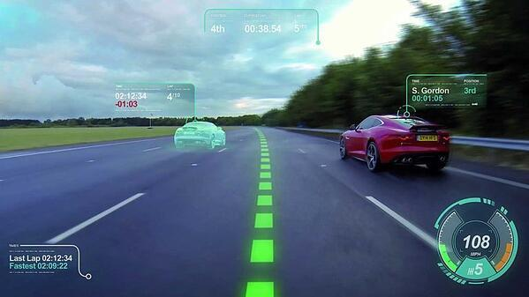

This example of outlining AR tells the driver exactly where the middle of the lane is to keep them out of harm's way. Similar applications include parking your car and having the boundaries outlined so that you can see exactly where the parking space is.

# What is Virtual Reality?[2]

Today the Virtual reality (VR) technology is applied to advance fields of medicine, engineering, education, design, training, and entertainment. VR is a computer interfaces which tries to mimic real world beyond the flat monitor to give an immersive 3D (Three Dimension) visual experiences. Often it is hard to reconstruct the scales and distances between objects in static 2D images. Thus the third dimension helps bringing depth to objects.

## Virtual Reality (VR) vs Agumented Reality (AR)

Augmented Reality (AR) that places computer generated objects on top of real world to make it more meaningful and interacting with it. The good example of AR would be PokemonGo game and IKEA app. The IKEA app uses camera so users can visualize the products being placed at their home.  
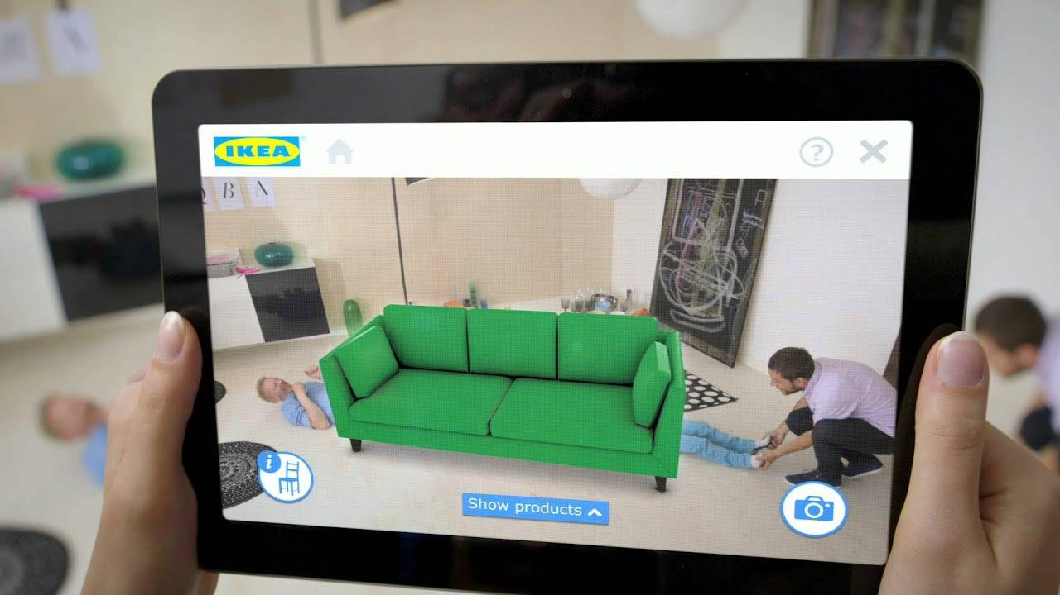VR and AR, they don’t have winners or losers as they are being better in their respective way of use. VR, for example, is terrific for gaming and watching video. Being able to fully immerse yourself is incredible, and nearly all the experiences wouldn't feel the same in AR. At the same time, the ability to interact with the physical world while seeing elements of the virtual world is fantastic for productivity and some forms of entertainment, and long term could be a default for how we interact with all kinds of computer interfaces.

**History of VR**

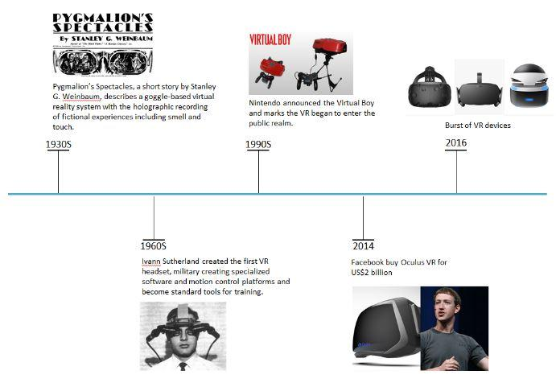Following are brief history of Virtual Reality:

|  |  |
| --- | --- |
| **Year** | **Developments** |
| 19th century | Panoramic paintings : VR technology started with the introduction of 360 panoramic paintings from 19th century. These paintings filled the viewer’s entire field of vision making it an immersive scene. |
| 1838 | Stereoscopic photos and viewers: Charles Wheatstone demonstrated that viewing different two-dimensional (2D) images side by side through a stereoscope gave the user a depth and immersion. The brain processes these two images from each eye into a single object of 3D. Later it was used for virtual tourism. |
| 1930s | Pymalion’s Spectables, a short story by Stanley G. Weinbaum presented an idea of google-based virtual reality world through holographics, smell, taste and touch making hi a true visionary of the field. |
| 1960s | Ivann Sutherland created the first VR Head Mounted Display with specialized software and motion control platforms which became standard for training. |
| 1987 | The name “Virtual Reality” was coined by Jaron Lanier, founder of Visual Programming Lab (VPL). |
| 1993 | Sega VR headset was announced for Sega Genesis console at Consumer Electronics show. However, it was a huge flop for Sega because it did not go further from prototype phase despite having four games developed for it. The prototype headgear had head tracking, stereo sound and LCD screens. |
| 1995 | The Nintendo Virtual boy (VR-32) marked the walkthrough of VR in public realm. It was first ever portable console displaying true 3D graphics for gaming console but it lacked software support and was uncomfortable. |
| 1999 | The Matrix, the Wachowski siblings’ film featured characters living in simulated world depicting VR. It was major cultural impact and introduced VR into the mainstream |
| 21st century | The boom of smartphones with high density displays and 3D graphics capabilities has made a new generation of lightweight and practical VR devices possible. The video game industry developed consumer VR unabated. Depth sensing cameras suites, motion controllers and natural human interfaces are already in market for daily human-computer interaction. |
| 2014 | Facebook bought Oculus VR and developing a VR chat rooms for future. |
| 2017 | Burst of different VR devices in the commercial market. |

# VR Components

## Hardware

The hardware produces stimuli that override the senses of the user [22] based on human motions. The VR hardware accomplishes this by using sensors for tracking motions of user such as button presses, controller movements, eye and other body part movements. It also considers the physical surrounding world because only engineered hardware and software does not constitute the complete VR system. The organism (users) and its interaction with the hardware is equally important.

VR hardware constitute of sensors which act as transducer to convert the energy it receives into a signal from an electrical circuit. This sensor has receptor to collect the energy for conversion and organism has sense organs such as eyes and ears for the same purpose. As the user moves through the physical world, it has its own configuration space which are transformed or configured correspondingly.

## VR Devices

VR devices are the hardware products used for VR technology to happen. The different key components of VR system are discussed below. The figure (number) shows the high-level view of Virtual World Generator (VWG). The inputs are received from the user and his surroundings and appropriate view of the world are rendered to displays for VR experiences.

### Personal Computer (PC)/Console/Smartphone

Computers are used to process inputs and outputs sequentially. To power the content creation and production significant computing power is required, thereby making PC/consoles/smartphones important part of VR systems. The VR content is what users view inside and perceive so it is equally important as other hardwares.

### Input devices

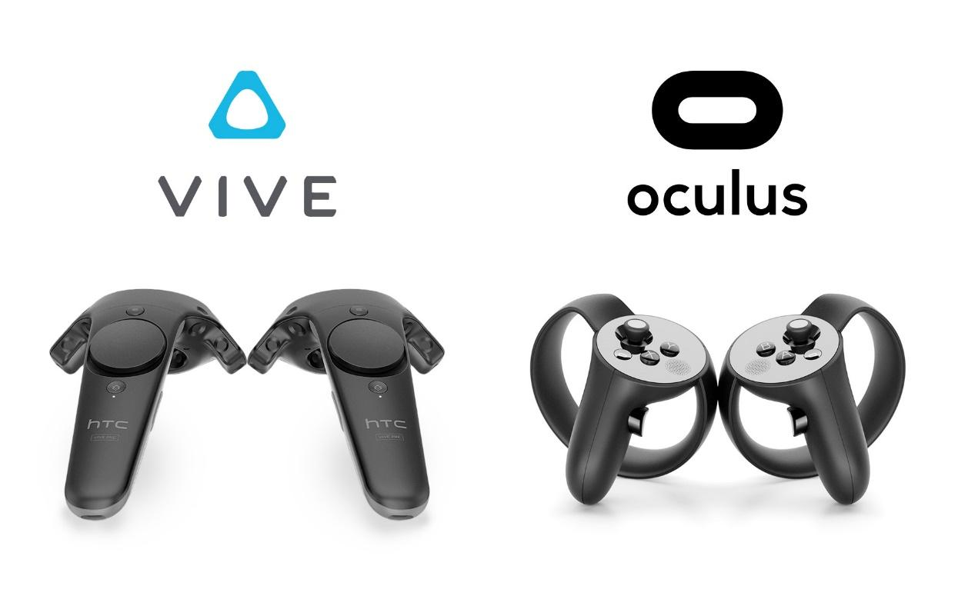Input devices provides users the sense of immersion and determines the way a user communicates with the computer. It helps users to navigate and interact within a VR environment to make it intuitive and natural as possible. Unfortunately, the current state of technology is not advanced enough to support this yet. Most commonly used input devices are joysticks, force Balls/Tracking balls, controller wands, data gloves, trackpads, On-device control buttons, motion trackers, bodysuits, treadmills and motion platforms (virtual omni).

### Output Devices

Devices that each stimulate a sense organ. Output devices are used for presenting the VR content or environment to the users and it is utmost devices to generate an immersive feeling. These include visual, auditory or haptic displays. Like input devices, the output devices are also underdeveloped currently because the current state-of-art VR system does not allow to stimulate human senses perfect ideal manners. Most systems support visual feedback, and only some of them are enhanced it by audio or haptic information.

## Software

Apart from input, output hardware and its coordination, the underlying software is also equally important . It is responsible for the managing of I/O devices, analyzing incoming data and generating proper feedback . The whole application is time-critical and software must manage it: input data must be handled timely and the system response that is sent to the output displays must be prompt in order not to destroy the feeling of immersion. The developer can start with basic software development kit (SDK) from a VR headset vendor and build their own VWG from scratch. SDK usually provide the basic drivers, an interface to access tracking data and call graphical rendering libraries. There are some ready-made VWG for particular VR experiences and has options to add high-level scripts.

### Audio

Virtual reality audio may not be as technically-complex as the visual components, however, it is an equally important component to stimulate a user’s senses and achieve immersion. Most virtual reality headsets provide users with the option to use their own headphones in conjunction with a headset. Other headsets may include their own integrated headphones. Virtual reality audio works via positional, multi-speaker audio (often called Positional Audio) that gives the illusion of a 3-dimensional world. Positional audio is a way of seeing with your ears and is used in virtual reality because it can provide cues to gain a user’s attention, or give them information that may not be presented visually. This technology is already quite common and often found in home theater surround sound systems.

### Human Perception

Understanding a physiology of the human body and the optical illusions are important to achieve maximum human perceptual without side effects. The human senses using different stimulus, receptor and sense organ.   
As virtual reality are supposed to simulate the real world, it is important to know how to “fool the user’s senses” to know what are the most important stimuli and what is the accepted quality for subjective viewing? Human vision provides the most of information that are passed to our brain followed by hearing, touch and other senses. System synchronization of all stimuli with user’s actions are also responsible for proper functioning of VR system.

### Content Creation

After understanding how the different senses, stimulus and sense organ works together to provide virtual reality to the user it is also vital to know how it works technically.

### Taking a 360-degree immersive videos

Taking 360-degree video is the easiest means of creating VR content. In case of 360 videos you will not be able to interact with the environment except for looking around. We also can see lots of 360 videos and it is now supported in Facebook and Youtube. Which has enabled people to upload lots of content online.

video you will require a special 360 camera and with better resolution. Next step is filming where you need to maintain camera in still position or with even motion, else it would cause motion sickness for the viewer. You can also edit your video using softwares to reduce any issues while filming.

### Making a 3D animation or construction

Taking 360-degree video will enable us to create content of real world but if we want to create more advanced and interactive application. Compared to 360-degree video which will let user view world from one point, 3D creation can allow us to create content where users can move in virtual world.

3D model of real world and develop the experience. The other way is use game engine like Unity and Unreal Engine. There are lot of engine available now which would allow developers not only to create game but also for other 3D construction.

## Field of View

Field of View (FOV)refers to how wide the picture is [Chinese girl ref] and is measured based on the degree of display. It also provides a realistic perception of the environment landscape. Today the most high-end headsets has 100 or 110 degree which is sufficient for most of the VR content available.

## Frame rate

“Frame rate refers to the frequency (rate) at which the display screen shows consecutive images, which are also called frames”. In VR, minimum frame rate required is approximately 60 frames per second to avoid content stuttering or other side effects to users and to have a lifelike experience. Frame rates for VR headsets will increases inevitalbly in future providing more realistic experience.

## Latency

The immersive applications also depends on naturalness of the simulation. Latency refers to the amount of time it takes for an image displayed in a user’s headset to catch up to their changing head position. Latency can also the thought of as a delay, and is measured in milliseconds (ms). In order for an experience to feel real, latency usually needs to be in the range of 20 milliseconds (ms) or less. Low latency is needed to make the human brain accept the virtual environment as real.

# Applications[3]

With the advancement in display, sensing and computer technology, it gives the user a new VR experiences which are more realistic and immersive for different VR applications. VR can lead to new and exciting discoveries in different fields. There are wide range of applications for VR which includes:

## Entertainment

The potential of VR in entertainment is clear and huge as the entertainment industry is a multi-billion dollars and consumers are always interested on its novelty.  
The VR video game world was popularized already by the Disney Movie Tron in 1982. Today the video games are explored in large and realism world through an avatar. In VR games, gamers can look in any direction or walk through the scene.

Hollywood movies offers increasing degrees of realism to make user feel like they are part of the scene. They let the user totally immerse in computer generated world with the help of HMD that supports a stereoscopic view of the scene accordingly to the user’s position and orientation enhanced by audio, haptic and sensory interfaces.

## Education

In addition to creating social awareness, the first-person perspective could revolutionize education scenario we have today. Anything that is too dangerous, expensive, or impractical to do in reality, virtual reality is the solution. VR offers visualisation of geometric relationships in difficult concepts or data that are hard to interpret. If the real environment is costly or hazardous to health, VR is the best choice to understand and learn it. For example, flight simulation or firefighting, nuclear power plant safety, medical procedures etc are the training in VR which are useful for education. Not just these common uses, VR education includes history, anthropology and foreign language acquisition. Students can explore the streets in 17th-century, on different era rather than just reading a book.

## Health

VR technology can also help improve today’s distributed health care system, in which doctors train to perform routine medical procedures in remote communities around the world. Doctors can immerse themselves in 3D organ models that were generated from medical scan data for better planning and preparation for a medical procedure. It can also be used to explaining the patient and his family so that they make more informed decisions. VR can also provide therapy to people suffering from mental illness.

## Manufacturing

The manufacturing industry have used virtual realty to the models and design it before implementing it.

## Tourism and Advertisment

Virtual Reality has been used to create histrorical sites, which then enables users to experience it with comfort from your house. For instance you can even create the war that happened at and location and feel being in war.

1. <https://learn.g2.com/augmented-reality>
2. <http://web.tecnico.ulisboa.pt/ist188480/cmul/introduction.html>
3. <http://web.tecnico.ulisboa.pt/ist188480/cmul/application.html>